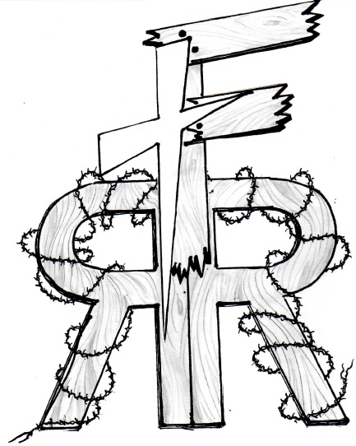 |  | Freedom Reins  - Ranch  - Feb 2014
Hope…Guide…Trust…persevere |  | In This Issue

We had a great year here at the Ranch. We had a number of new children join our program. I have seen a difference in all the children that come out, and their parents/other adults in their lives say the same.
We also had the Abilene School for the Blind come out with 8 kids earlier in the year. The kids did a great job with the horses. One child, who was legally blind, even found the courage to ride a horse! That was amazing to take part in! Can you imagine climbing up in a saddle about 4 or 5 feet off the ground, without being able to see? You don’t really have a complete picture of what the horse looks like, what is around you, or how far you might fall. Yet still, somehow this brave boy found the strength of character to climb up in the saddle and go for a ride. The courage that this boy and all the other children from the School of the Blind showed me that day was incredible.
This year also saw in influx of possible volunteers and of gifts to the Ranch. We have a Men’s group from Beltway Park Baptist Church that has let the Men and their families know that we are looking for volunteers to help out at the Ranch. We had an initial meeting and about a dozen people showed up and said they would be willing to help in various ways: from riding and training horses, to help fixing fences or putting up some run-in shelters in the pastures, to fixing the welding machine that doesn’t work anymore. We are extremely grateful to everyone that has already volunteered time out here, and to all those who will do so in the future. We were also hoping to build some benches for children and adults to sit on while they were here. The Lord answered that prayer too in the form of a donation of a picnic table and several bench seats with cushions from a couple. That was an unexpected surprise answer to prayer. We have also had a youth saddle donated to us. This is also amazing, because we only had 1 small children’s saddle, and the rest of our saddles were adult saddles.
This past year we have also upgraded our website through a gift from Pioneer Drive Baptist Church and through Sergeant Services, a local website hosting company.
The Lord has been slowly growing this ministry and we rely on His hand of blessing to continue to operate. We look forward to another exciting year in His employ.
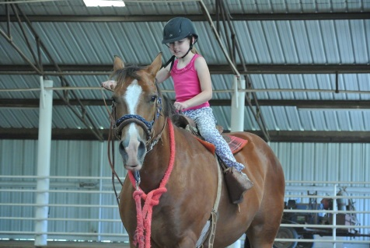

Year in review
by Mike Roetheli
Year in review
What have we accomplished in the last year?
Page 1
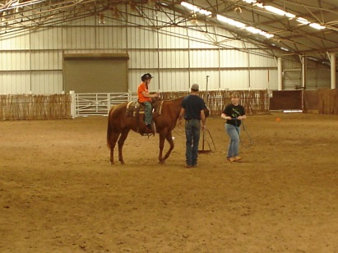
Deception
Whose voice are we following, the Good Shepard, or someone else?
Page 2

Deception
by Mike Roetheli
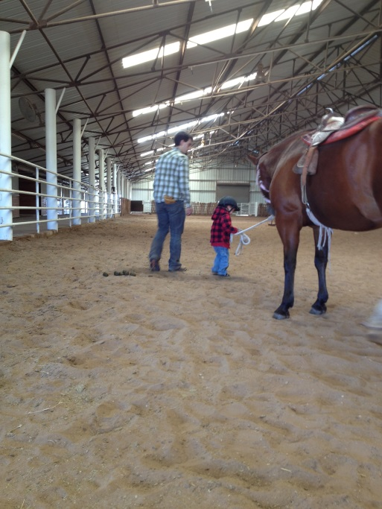
I have a confession: whenever it is time for a child to come to the Ranch, I have a part of me that dreads it. I don’t want to stop what I’m doing and give my time and energy to working with the kids. Then the questions start coming, “what if I don’t know what to say, what if I do something wrong, what if the horses are skittish today and a child falls,?” The accusations usually are there as well: Why do you think you have anything to offer the kids? You don’t know what you’re doing, so you might as well give up. You aren’t ready for this; you need to get more experience before you can really do this. Pushing through these conflicting emotions and questions, I slowly go to put on my boots. As I go out to the pasture to collect the horses, or go up to the arena, I try to force myself to a happier place. I start praying over the Ranch, the horses, and the child that is coming that day. The questions and accusations may grow louder, or they may diminish, but are still there none the less. The child is coming, what am I going to do? I don’t know, but ask Jesus to come into this place and help me to do whatever the child needs that day. My feelings of not being able usually stay with me until the child arrives. I smile and offer a warm “Hi” to the child and the adult that brings them. Then the questions and accusations disappear. I am in the moment with the child and the focus is taken off me. Huh. Isn’t that the problem in the first place? My focus isn’t in the right place. It is on me, myself, and I, not where it should be…on Jesus. He said that He would be with us, even to the very ends of the Earth, so I suppose that Clyde, TX would fall within that promise. God has a plan for the Ranch, a good plan, but there is another that has plans for the Ranch as well. The Deceiver. He would love nothing more than to not have this Ranch in operation. He doesn’t want kids to come here and be in the presence of the Holy Spirit, be prayed over, and feel the love of the Father. The Deceiver doesn’t want to do anything but kill, steal, and destroy. And this Ranch was set up to bring life to both children and adults. The lies that are told to me, to all of us, are a set up. If the Deceiver can stop God’s plan before it starts, then he wins. No, he doesn’t win, because we know that Jesus already won everything, but Satan still can try to hurt us. So I, and you, must not listen to all the lies that come into our thoughts when we are doing what we have been called to do. The deception seems so persuasive, so right, in the moment. But we must not fall for the lies. We must bring the words and promises from God to mind to battle those lies. The deception won’t work when exposed to the light of Jesus. “Jesus protect our minds from the lies of the enemy.” “So let's not get tired of doing what is good. At just the right time we will reap a harvest of blessing if we don't give up” (Gal 6:9).

Ways to Help

- Pray for the Ranch: That we will continue to do God’s work. That the right kids will come out. For everyone’s safety, and for volunteers to help.
- Volunteer: We can use volunteers who want to help. We need people with willing hearts—we can teach you the rest! We need people who already can ride horses, or people who want to learn. We need a horse trainer. We need people who want to help create and tend a garden. We will also be building some 3-sided shelters for the horses sometime soon; we will need people who can, weld, use screw guns, etc.
- Donate: We have a list of items we need on the website, but we are in need of youth saddles, training reins, helmets, saddle blankets, and horse care items like brushes, buckets, etc. We are a non-profit organization that depends on the public for monetary support. You can send a check, or go online to our website and donate through Paypal.

